**Project Sprint Retro Notes**

**Team:** 4

**Sprint:** 1

**Date:** 15/09/20

**Attended:** Will Guida, Grace Kerr, Alin Cimpean, Angela Alviano, Su-Kuen Koh

**Scrum Master:** Alin Cimpean

**Product Owner:** Sachin

**Development team:** Will Guida, Grace Kerr, Alin Cimpean, Angela Alviano, Su-Kuen Koh

## **1. Things That Went Well**

Each team (backend and frontend) worked well together in establishing the foundations of the application. The backend team was able to implement a suitable and extendable API that now connects and speaks to the frontend implementation. The frontend team has been able to also design and implement a working form that successfully creates a User account and stores it in the h2 database.

## **2. Things That Could Have Gone Better**

Getting more done on the frontend side to have more functionality. However now that the frontend team has been able to connect to the backend API at the end of the sprint, we can now continue with properly implementing the features

## **3. Things That Surprised Us**

We were surprised by the level of coordination needed to successfully tie in frontend and backend functionalities, and the amount of independent research needed to find and debug errors in implementation and testing.

We were also surprised by the speed at which the sprint timebox unfolded, and we did not end up implementing all the functions that we originally planned. (We plan to complete them in the upcoming sprint.) We now feel we have become more accustomed to and settled into a Scrum routine, and better understand the quick turnaround needed from planning to implementation and testing.

## **4. Lessons Learned**

This sprint was always going to be a proper test in how much we were actually able to get done. While some sprint items were not completed (sprint backlog items #5 predominantly) it has given us a better idea of what we can complete as a team within a sprint. Moving forward, we will try and compile our sprint backlog with more feasible items.

## **5. Burndown Chart**

We started off the sprint very well putting in a lot of hours which we did not plan for, however towards the end of the sprint we had begun to do less work on this assignment, largely due to either mid semester tests or the mid semester break, after those however we picked it back up and managed to complete the sprint in time as detailed from the burndown chart below.

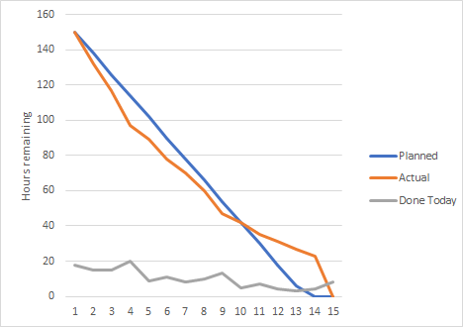

## **6. Final Thoughts**

Our final thoughts are that as a team we worked well together and tasks were delegated perfectly to our strengths. We will continue to do this but ensure that those tasks aren’t concrete and others are allowed to jump in and help when it is needed. Now that the frontend and backend are successfully working together we will be able to implement more functionality into our website.

## **7. Things to Change**

We are likely to change the schema of our current database (model classes) to better suit the functionality we are trying to implement. This was always likely to happen the further both the frontend and backend teams developed the application with various decisions being made about certain aspects and site-workflow.